Table of Contents
Connecting The Hardware: 2
Connecting the LED panels together: 2
Connecting the LEDs to the receiver card: 2
Connecting the LEDs to the power supply: 3
Connecting the receiver card to the power supply: 4
Connecting the TB40 sending card to the receiver card: 4
Connecting the TB40 sending card to the PC HDMI: 4
NovaLCT Application: 5
NovaLCT Software: 5
Connecting to the application: 5
TB40 Sending Card Configuration: 6

Connecting The Hardware:

Connecting the LED panels together:
- Row 1:
  - Lay the panels face down on a soft surface, connect a ribbon cable between the “JOUT” port on the first display to the ”JIN” port on the next display. The cable is keyed and will only insert one way.
  - Stop after the last panel in the row has been connected.
- Row 2:
  - Lay the panels face down on a soft surface, connect a ribbon cable between the “JOUT” port on the first display to the ”JIN” port on the next display. The cable is keyed and will only insert one way.
  - Stop after the last panel in the row has been connected.

Connecting the LEDs to the receiver card:
THERE IS A RISK OF DAMAGE TO THE CARD OR LEDS IF CONNECTED WRONGLY.
Use the following receiver card image as a guide to connect the LED panels.
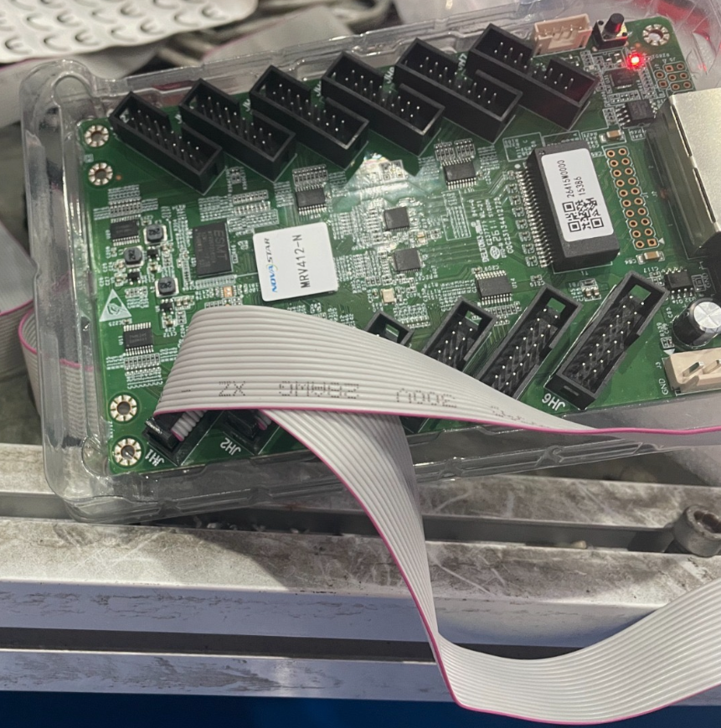
- Row 1 – IT IS VITALLY IMPORTANT TO DO THIS STEP CORRECTLY:
  - Find socket “JH1” on the receiver card and attach one end of the ribbon cable. The cable is keyed and will only insert one way.
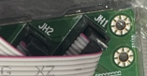

  - Route the ribbon cable to the FIRST row of LED panels and plug in into the “JIN” socket. The cable is keyed and will only insert one way.
- Row 2 – IT IS VITALLY IMPORTANT TO DO THIS STEP CORRECTLY:
  - Find socket “JH2” on the receiver card and attach one end of the ribbon cable. The cable is keyed and will only insert one way.

  - Route the ribbon cable to the SECOND row of LED panels and plug in into the “JIN” socket. The cable is keyed and will only insert one way.

Connecting the LEDs to the power supply:
Connect the +ve and -ve terminals of the power supply to the power plug (labelled “POWER”) on the rear of each individual LED panel.
The plug is keyed and will only install one way.

Connecting the receiver card to the power supply:
Connect the +ve and -ve terminals of the power supply to the +ve and -ve inputs on plug J4 of the receiver card.
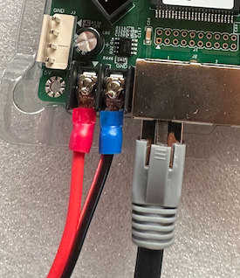

Connecting the TB40 sending card to the receiver card:
The sending card is connected to the receiving card by a CAT6 or CAT6a ethernet cable.
The cable should be inserted into port 1 of the TB40 sending card and port 1 of the receiving card.

Connecting the TB40 sending card to the PC HDMI:
A standard HDMI cable connects the TB40 sending card to the secondary HDMI port.
The PC must be configured to duplicate the displays.

NovaLCT Application:
The clock display needs to be visible on the LED display, this is achieved by mirroring a part of the main display that connects to the TB40 sending card, which communicates the mirrored data to the LED.
The TB40 must be configured to access a small part of the main display using NovaLCT, a software application used to program the TB40, connecting it to the top LHS of the primary PC display.

NovaLCT Software:
The windows version of the application is available in the “tools” folder inside the project_atlas folder in a zip file.

Connecting to the application:
- Wired:
  - Connect a USB type B cable to the TB40 and connect the other end to a free PC USB port.
- Wireless:
  - Search for SSID T40 (some zeros and then an 8 I think)
  - Password is SN2008@+
When connected correctly the user interface of NovaLCT will change to give access to the configuration menu.

TB40 Sending Card Configuration:
Step 1: Log in
Using novaLCT to configure four 32x16 led panels as 2 rows of 2 columns mapping to the main pc screen from position 0,0 (top left)
- Open NovaLCT.
- Click User on the top menu bar → select Media Player Login.
- Enter the username admin and password SN2008@+ and click Login.
- Select T40_00000159 and click on Connect System.
- Click the Screen Configuration button on the main dashboard and click next on the popup.

Step 2: Set the LED module size (Receiving Card)
You are now in the Screen Configuration window. Click on the second tab, Receiving Card.
- Look for the Cabinet Information section.
- Set the Width (Pixel) to 32 (matching the number of LEDs in each row of a single module).
- Set the Height (Pixel) to 16 (matching the number of LEDs in each column of a single module).
- Click Save at the bottom of the section to program the TB40 sending chip.

Step 3: Define the Grid (Screen Connection Tab)
Switch to the third tab at the top labeled Screen Connection. This is where we tell NovaLCT how the physical panels are arranged. [1]
- Configure Screen Quantity: Under "Quantity of Screens" (top RHS), set the value to 1 and click Configure.
- Click on the “Complex Screen” radio button to change the view to the manual configuration view

Step 4: Map the Screen Coordinates and Data Cable Connection
To tell NovaLCT how the physical Cat6 cable travels out of the TB40 port and through the LED panels.
The table on the RHS of the screen contains all of the details required to inform the tb40 what information to display and how to display it, as described below:
Sending Card | Port | Receiving Card | Starting X | Starting Y | Width | Height
1 | 1 | 1 | 0 | 0 | 64 | 32
1 | 1 | 2 | 64 | 0 | 64 | 32
1 | 1 | 3 | 0 | 32 | 64 | 32
1 | 1 | 4 | 64 | 32 | 64 | 32

Sending Card: The number assigned to the TB40, in this case “1”
Port: The port that the ethernet cable is plugged in to on the TB40, in this case Port 1
Receiving card: The number assigned to the receiver card connected to the TB40.
Starting X & Y: The xy coordinates of the main screen that will be mirrored by the LED screen, in this case it is the very top LHS of the main PC display, coordinate x=0 and y=0.
Width & Height: This denotes the size of the total LED display, in this case 64 pixels by 32 pixels.
The config shown above will mirror everything that appears on the main PC screen from the top left, across 64 pixels and down 32 pixels.

Step 5: Save and Send to Hardware
- Click Send to HW (Hardware) at the bottom right.
- A success prompt will appear; your LED wall should now display a tiny 64 × 32 pixel snippet of your desktop's top-left corner.
- Crucial Final Step: Click Save right next to the Send button. If you skip this, your screen configuration will erase completely the next time the TB50 loses power.

The clock display must be reduced in size so that it fills a space of 64 pixels by 32 pixels and it should automatically be deployed to the top LHS of the display (0,0) at startup.

